Design

Document

Order My Cake.

**Index**

|  |  |  |
| --- | --- | --- |
| Sr No | Content | Page No |
| 1 | Introduction | 3 |
| 2 | Architectural Design | 3 |
| 3 | High Level Design | 6 |
|  | 3.1 E-R Diagram | 6 |
|  | 3.2 Page Navigation Diagram | 7 |
|  | 3.3 Data Flow Diagram | 9 |
|  | 3.4 Deployment Diagram | 12 |
| 4 | Low Level Design | 13 |
|  | 4.1 Database Design | 13 |
|  | 4.2 Stored Procedure | 16 |
|  | 4.3 Details Of Page Navigation | 17 |

* **Introduction:**

This document is meant for the description of the structure and the database which we are using in this project. This document gives brief description about Architecture of the system, E-R diagram of the system and the table descriptions, the page navigation diagrams and the detail description for the page navigation.

* **High Level Design:**
* **E-R Diagram:**

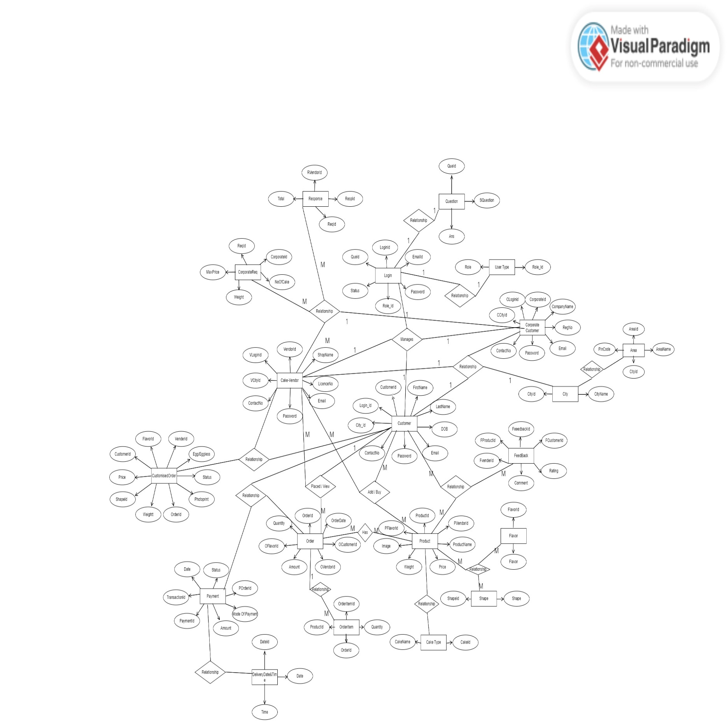

Above E-R Diagram shows that database of Order My Cake system consists of following entities:

* **UserType**

This entity contains the Role_Id and Role.

|  |  |
| --- | --- |
|  |  |

* **Login**

This entity contains the LoginId, Email, Password, Status, Ans, QueId, Role_Id.

* **City**

This entity contains the CityId, CityName.

* **Area**

This entity contains the AreaId, AreaName, Pincode, CityId.

* **Question**

This entity contains the QueId, SQuestion.

* **Customer**

This entity contains CustomerId, FirstName, LastName, DOB, ContactNo, AddressLine, AreaId, Login_Id.

* **CorporateCustomer**

This entity contains CorporateId, CompanyName, RegNo, ContactNo, AddressLine, CAreaId, CLogin_Id.

* **Vendor**

This entity contains VendorId, ShopName, LicenceNo, ContactNo, Customisation, AddressLine, VAreaId, VLogin_Id.

* **Product**

This entity contains ProductId, ProductName, Price, Weight, Image, Egg/Eggless, Description, ShapeId, PVendorId, PFlavorId, CakeId.

* **Shape**

This entity contains ShapeId, Shape.

* **Flavor**

This entity contains FlavorId, Flavor.

* **CakeType**

This entity contains CakeId, CakeName.

* **Order**

This entity contains OrderId, OrderDate, Status, Amount, Delivery Date and Time, OCustomerId, OVendorId.

* **CustomisedOrder**

This entity contains COrderId, weight, CShapeId, Egg/Eggless, PhotoPrint, Status, Price, CCustomerId, CVendorId, CFlavorId.

* **OrderItem**

This entity contains OrderItemId, Quantity, OrderId, OProductId.

* **Payment**

This entity contains PaymentId, Amount, PaymentMode, PDate, TransactionId, Status, POrderId.

* **Feedback**

This entity contains FeedbackId, Rating, Comment, FCustomerId, FVendorId, FProductId.

* **CorporateReq**

This entity contains ReqId, NoOfCakes, Weight, MaxPrice, RCorporateId.

* **VendorResponse**

This entity contains ResId, TotalPrice, ReqId, RVendorId.

* **Low Level Design:**
* **Database Design:**

**1] UserType**

|  |  |  |  |  |
| --- | --- | --- | --- | --- |
| **Field** | **Type** | **Null** | **Key** | **Description** |
| Role_Id | Integer | No | Primary key | Role Id of user |
| Role | Varchar (45) | No |  | Login users |

**2] Login**

|  |  |  |  |  |
| --- | --- | --- | --- | --- |
| **Field** | **Type** | **Null** | **Key** | **Description** |
| LoginId | Integer | No | Primary key | Loginid |
| Email | Varchar (45) | No |  | email |
| Password | Varchar (45) | No |  | Password |
| Status | tinyint | No |  | Enabled / Disabled |
| Ans | Varchar(45) | No |  | Answer of security question |
| QueId | Integer | No | Foreign key | Reference to QueId (question) |
| Role_Id | Integer | No | Foreign key | Reference to Role_Id (usertype) |

**3] City**

|  |  |  |  |  |
| --- | --- | --- | --- | --- |
| **Field** | **Type** | **Null** | **Key** | **Description** |
| CityId | Integer | No | Primary key | CityId of city |
| CityName | Varchar (45) | No |  | city name |

**4] Area**

|  |  |  |  |  |
| --- | --- | --- | --- | --- |
| **Field** | **Type** | **Null** | **Key** | **Description** |
| AreaId | Integer | No | Primary key | Areaid of Area |
| AreaName | Varchar (45) | No |  | Name of Specific area |
| Pincode | Integer | No |  | Pincode |
| CityId | Integer | No | Foreign key | Reference to CityId (City) |

**5] Question**

|  |  |  |  |  |
| --- | --- | --- | --- | --- |
| **Field** | **Type** | **Null** | **Key** | **Description** |
| QueId | Integer | No | Primary key | Id of Security Question |
| SQuestion | Varchar (45) | No |  | Security Question |

**6] Customer**

|  |  |  |  |  |
| --- | --- | --- | --- | --- |
| **Field** | **Type** | **Null** | **Key** | **Description** |
| CustomerID | Integer | No | Primar key | Id Of Customer |
| FirstName | Varchar (45) | No |  | FirstName of Customer |
| LastName | Varchar (45) | No |  | LastName of Customer |
| DOB | date | No |  | DOB |
| ContactNo | Varchar(12) | No |  | Contact no. |
| Address | Varchar(100) | No |  | Adress |
| AreaId | Integer | No | Foreign key | Reference to AreaId(area) |
| Login_Id | Integer | No | Foreign key | Reference to Login_Id(Login) |

**7] Corporate Customer**

|  |  |  |  |  |
| --- | --- | --- | --- | --- |
| **Field** | **Type** | **Null** | **Key** | **Description** |
| CorporateID | Integer | No | Primary key | CorporateID |
| CompanyName | Varchar (45) | No |  | CompanyName |
| RegNo | Integer | No |  | Registration No of Company |
| ContactNo | Varchar(12) | No |  | ContactNo |
| CAreaId | Integer | No | Foreign key | Reference to AreaId(area) |
| CLoginid | Integer | No | Foreign key | Reference to Loginid(Login) |

**8] Vendor**

|  |  |  |  |  |
| --- | --- | --- | --- | --- |
| **Field** | **Type** | **Null** | **Key** | **Description** |
| VendorID | Integer | No | Primary key | VendorID |
| ShopName | Varchar (45) | No |  | Name of Shop |
| LicenceNo | Varchar (45) | No |  | LicenceNo Of shop |
| ContactNo | Varchar(12) | No |  | ContactNo |
| Customisation | tinyint | No |  | Enabled / Disabled |
| VAreaId | Integer | No | Foreign key | Reference to AreaId(area) |
| VLoginid | Integer | No | Foreign key | Reference to Loginid(Login) |

**9] Product**

|  |  |  |  |  |
| --- | --- | --- | --- | --- |
| **Field** | **Type** | **Null** | **Key** | **Description** |
| ProductId | Integer | No | Primary key | ProductId |
| ProductName | Varchar (45) | No |  | ProductName |
| Price | double | No |  | Price |
| Weight | double | No |  | Weight |
| Image | blob | No |  | Image |
| Egg/Eggless | tinyint | No |  | Enabled / Dissabled |
| Description | Varchar (45) | No |  | Description |
| ShapeId | Integer | No | Foreign key | Reference to ShapeId(Shape) |
| PVendorId | Integer | No | Foreign key | Reference to VendorId(Vendor) |
| PFlavorId | Integer | No | Foreign key | Reference to FlavorId(flavor) |
| CakeId | Integer | No | Foreign key | Reference to CakeId(CakeType) |

**10] Shape**

|  |  |  |  |  |
| --- | --- | --- | --- | --- |
| **Field** | **Type** | **Null** | **Key** | **Description** |
| ShapeID | Integer | No | Primary key | ShapeID |
| Shapes | Varchar (45) | No |  | Shapes of the products |

**11] Flavor**

|  |  |  |  |  |
| --- | --- | --- | --- | --- |
| **Field** | **Type** | **Null** | **Key** | **Description** |
| FlavorId | Integer | No | Primary key | FlavorId |
| Flavor | Varchar (45) | No |  | Flavor of Given product |

**12] Cake Type**

|  |  |  |  |  |
| --- | --- | --- | --- | --- |
| **Field** | **Type** | **Null** | **Key** | **Description** |
| CakeId | Integer | No | Primary key | cake id |
| CakeName | varchar | No |  | cake name |

**13] Order**

|  |  |  |  |  |  |
| --- | --- | --- | --- | --- | --- |
| **Field** | **Type** | **Null** | **Key** | **Default** | **Description** |
| OrderId | Integer | No | Primary key |  | Orderid |
| OrderDate | Datetime | No |  | curdate | Date |
| Status | tinyint | No |  |  | Enabled / Disabled |
| Amount | double | No |  |  | cost of product |
| OCustomerId | Integer | No | Foreign key |  | Reference to CustomerId(Customer) |
| OVendorId | Integer | No | Foreign key |  | Reference to VendorId(Vendor) |

**14] CustomizedOrder**

|  |  |  |  |  |
| --- | --- | --- | --- | --- |
| **Field** | **Type** | **Null** | **Key** | **Description** |
| COrderId | Integer | No | Primary key | COrderId |
| Weight | double | No |  | weight of Product |
| Egg/Eggless | tinyint | No |  | Enabled / Disabled |
| PhotoPrint | tinyint | No |  | Enabled / Disabled |
| Status | tinyint | No |  | Enabled / Disabled |
| Price | double | No |  | price of product |
| CShapeId | Integer | No | Foreign key | CShapeId |
| CCustomerId | Integer | No | Foreign key | Reference to CustomerId(Customer) |
| CVendorId | Integer | No | Foreign key | Reference to VendorId(vendor) |

**15] OrderItem**

|  |  |  |  |  |
| --- | --- | --- | --- | --- |
| **Field** | **Type** | **Null** | **Key** | **Description** |
| OrderItemId | Integer | No | Primary key | OrderItemId |
| Quantity | Integer | No |  | Quantity ordered |
| OrderId | Integer | No | Foreign key | Reference to OrderId(Order) |
| OProductId | Integer | No | Foreign key | Reference to ProductId(Product) |

**16] Payment**

|  |  |  |  |  |
| --- | --- | --- | --- | --- |
| **Field** | **Type** | **Null** | **Key** | **Description** |
| PaymentId | Integer | No | Primary key | PaymentId |
| PaymentMode | varchar | No |  | Mode of Payment |
| PDate | Date | No |  | Payment Date |
| TransactionId | int | No |  | TransactionId |
| Status | tinyint | No |  | Enabled / Disabled |
| POrderId | int | No | Foreign key | Reference to OrderId(Order) |

**17] FeedBack**

|  |  |  |  |  |
| --- | --- | --- | --- | --- |
| **Field** | **Type** | **Null** | **Key** | **Description** |
| FeedbackId | Integer | No | Primary key | FeedbackId of Feedback |
| Rating | Integer | No |  | Rating given by users |
| Comment | Varchar(45) | No |  | Comment given by users |
| FCustomerId | Integer | No | Foreign key | Reference to CustomerId(Customer) |
| FVendorId | Integer | No | Foreign key | Reference to VendorId(vendor) |
| FProductId | Integer | No | Foreign key | Reference to ProductId(Product) |

**18] CorporateReq**

|  |  |  |  |  |
| --- | --- | --- | --- | --- |
| **Field** | **Type** | **Null** | **Key** | **Description** |
| ReqId | Integer | No | Primary key | ReqId |
| NoOfCake | Integer | No |  | NoOfCake required |
| Weight | double | No |  | Weight of per cake |
| MaxPrice | double | No |  | Afordable price |
| RCorporateId | Integer | No | Foreign key | Reference to CorporateId (CorpotateCustomer) |

**19] VendorResponse**

|  |  |  |  |  |
| --- | --- | --- | --- | --- |
| **Field** | **Type** | **Null** | **Key** | **Description** |
| RespId | Integer | No | Primary key | RespId of Vendor |
| TotalPrice | double | No |  | TotalPrice |
| ReqId | Integer | No | Foreign key | Reference to ReqId(CorpotateReq) |
| RVendorId | Integer | No | Foreign key | Reference to VendorId(Vendor) |